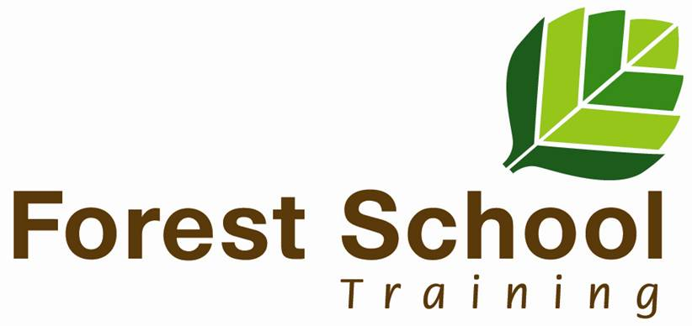
Forest School Training Collaborative
SCQF accredited training

CPD Training 2024

Fire and Tools

This two day course will work for you in different ways depending on where you’re starting from. We’ll be exploring how to use saws, knives, loppers, axes/wood splitters and drills to make a range of items, some of which we’ll use for working with fires. We’ll cover the basics of working safely and will support you in making things that will challenge and develop your skills. An active hands on course that will leave you feeling more confident in working with tools and fire.

Leader: Mike Brady
Chatelherault Country Park, 14th and 15th March 2024
Cost £200 per person. 12 places available on each course.

Experiences and Reviewing

So you’ve done an activity, think it went well but you want to delve a bit deeper and find out what your learners got out of it. Well this course will help you. There are many ways to review experiences and this course helps you explore the right technique, for the right group at the right time. Using some simple games and experiences as a basis we’ll get a good understanding of what reviewing can do and how you can use it to good effect. Over the course of the day we’ll explore verbal and non verbal techniques and also look at those that are suited to groups that find sharing feelings and thoughts challenging.

Leader: Mike Brady
Craufurdland Estate, Kilmarnock, 2nd February 2024
Cost £100 per person. 12 places.

Music in the Forest
Music bonds us together, it helps synchronise our bodies and brains. Being in the forest relaxes us and makes us feel good. Bring the two together and something really magical happens. Find out what by joining us on this course. Mike Brady, Forest School Trainer and Michael Philip, Music Teacher and Botanical Recorder for Lanarkshire will use their experiences to help you create your own instruments and guide you in putting them to good use in group performances. We’re expecting you to have some wonderful experiences on the course but we’re also expecting you to go away with the confidence and skills to create your own experiences with your own groups supported by access to our online resources.

Leader: Mike Brady and Michael Philip
Chatelherault Country Park, 23rd March 2024
Beechbrae Woodland Centre, 8th March 2024
Cost: £100 per person. 12 places on each course.

Ropes and Tarps

From play structures to practical shelters. From getting to grips with knots to working out how to manage without them. Few resources are more open ended that ropes or tarpaulins. This course will help you become confident in using them to support outdoor play as well as creating functional shelters for protection from the elements. Working with a mix of budget friendly equipment to more expensive equipment, and covering how to clean and maintain it, you’ll come away from this course with a good understanding of the qualities of both and the confidence to use whatever suits you best. You’ll also come away from this course with two 17m lengths of hempex rope so you can put your learning into practice straight away.

Leader: Mike Brady
Craufurdland Estate, Kilmarnock, 4th March 2024
Cost: £150, 12 places.

Managing Risk and Play in the outdoors
Playing outdoors has many benefits. Risky play outdoors has more benefits. But how do you manage this and keep your learners safe? This hands on course uses direct experience to help you explore ways you can manage risky play in your setting. We’ll cover swings, stick play, balancing, throwing and climbing on the course as the essentials and explore the risks and benefits of each of them and work out methods to manage them effectively.

Leader: Mike Brady
Balloch Castle Country Park, 26th April 2024
Cost: £100 per person, 12 places.

Unlocking Flow

You know that state of flow in which learners are so engrossed in an activity that they lose sense of time and no other activity matters during that time? Well that’s what we’re about on this course. How can you find ways to enter into that state yourself? How can you create the conditions to enable others to enter into that state? The answers lie within each of us and the answers are different for different people. Unlocking those answers, overcoming the barriers is a journey. This course will help you explore some of the common barriers to flow, discuss ways to overcome them and give you some direct experiences that may or may not lead to you getting into that flow state. You’ll come away with a solid toolkit to use along with access to additional resources on our Gurucan platform.

Leader: Mike Brady
Beechbrae Woodland Centre, 14th May 2024
Cost: £100 per person, 12 places.

About your trainer

Mike Brady is a director of Forest School Training Collaborative and a Forest School trainer since 2008. He’s recently taken early retirement and this has freed up time to develop more training – these CPD courses are the first fruits of that. While Forest School has been a big part of what he’s been involved in he’s also delivered a lot of outdoor play and green woodworking experiences and has worked with groups of all ages and backgrounds. The CPD courses have been designed to stand alone, you don’t need to be Forest School qualified to benefit from them. If you would like one of these courses delivered at your location or want something else then get in touch.

Booking

To book email mike@forestschoolscotland.co.uk. If you would like one of these courses delivered at your location or want something else then get in touch.

