Forest School Ethos

1) Long-term educational process
Forest School is a long-term student-led, educational process that promotes, observes and explicitly supports the social, emotional and physical development of children, young people and adults in an outdoor, preferably woodland environment.

2) Matching of tasks/activities to preferred learning styles
Key to supporting this process is an acknowledgement of the role of the practitioner as a ‘significant other’ who can encourage the development of self esteem through appropriate matching of task/activity to a student’s preferred learning style.

The development of the role of ‘significant other’ occurs through the long-term relationship that is built up over the duration of a Forest School programme (at least 12 weeks and preferably 36 weeks). This relationship is founded on the twin principles of risk and trust.

3) Continual detailed observation and evaluation
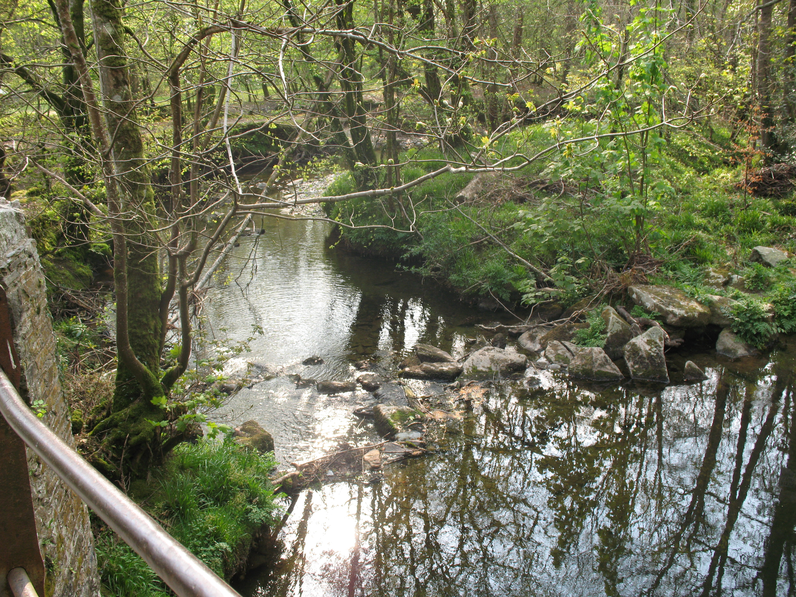
The successful matching of tasks/activities to a student’s preferred learning style occurs through continual detailed observation and evaluation of a student’s learning and behaviour over the duration of a Forest School programme.

This process of observation and evaluation begins with a ‘base-line assessment’ either provided by the referring agency or conducted during an initial period of Forest School (typically 6 weeks). Throughout the programme continuous observations are made, monitoring the daily progress of the students attending and which culminate in a detailed final report for each student on the Forest School Programme.

4) High staffing ratios
It is only through high staffing ratios that leaders are able to observe individual students, match tasks to preferred learning styles and work intensely with students on the Forest School Programme.

Forest School Criteria

Forest School:

- Is run by qualified Forest School Leader, who is adequately insured for the programmes that they run;

- Has regular and repeated participation in planned and well organised programmes (including planning for child-led learning/play) enabling participants to build on previous achievements and skills;

- Staff make detailed observations of individual participants, especially with respect to preferred learning styles and development of confidence, self-esteem and interpersonal skills;

- Is run in an outdoor setting for the bulk of the programme, ideally woodlands;

- Works with higher than average staff to pupil ratios for challenging/intensive activities;

- Introduces responsible risk taking and challenging norms;

- Sets participants up to achieve through small achievable tasks;

- The process of supporting students in a Forest School environment explicitly encourages Emotional literacy and the development of Emotional Intelligence.

- Forest School training enables students to integrate Forest School provision with ecologically sensitive and sustainable use of the outdoor environment.

